Design Analysis and Algorithm – Lab Work
Week 6

Question 1:Write a Program to perform Quick Sort using first element, middle element and random element.
Code:
#include <stdio.h>
#include <stdlib.h>
#include <time.h>
void swap(int *a, int *b) {
int temp = *a;
*a = *b;
*b = temp;
}
void printArray(int a[], int n) {
for (int i = 0; i < n; i++)
printf("%d ", a[i]);
printf("\n");
}
int partitionFirstPivot(int a[], int low, int high) {
int pivot = a[low];
int i = low + 1;
int j = high;
while (1) {
while (i <= high && a[i] <= pivot) i++;
while (a[j] > pivot) j--;
if (i < j)
swap(&a[i], &a[j]);
else
break;
}
swap(&a[low], &a[j]);
return j;
}
void quickSortFirstPivot(int a[], int low, int high) {
if (low < high) {
int p = partitionFirstPivot(a, low, high);
quickSortFirstPivot(a, low, p - 1);
quickSortFirstPivot(a, p + 1, high);
}
}
int partitionLastPivot(int a[], int low, int high) {
int pivot = a[high];
int i = low - 1;
for (int j = low; j < high; j++) {
if (a[j] <= pivot) {
i++;
swap(&a[i], &a[j]);
}
}
swap(&a[i + 1], &a[high]);
return i + 1;
}
void quickSortLastPivot(int a[], int low, int high) {
if (low < high) {
int p = partitionLastPivot(a, low, high);
quickSortLastPivot(a, low, p - 1);
quickSortLastPivot(a, p + 1, high);
}
}
int partitionRandomPivot(int a[], int low, int high) {
int randomIndex = low + rand() % (high - low + 1);
swap(&a[randomIndex], &a[high]);
return partitionLastPivot(a, low, high);
}
void quickSortRandomPivot(int a[], int low, int high) {
if (low < high) {
int p = partitionRandomPivot(a, low, high);
quickSortRandomPivot(a, low, p - 1);
quickSortRandomPivot(a, p + 1, high);
}
}
int main() {
srand(time(NULL));
int n, choice;
printf("Enter number of elements: ");
scanf("%d", &n);
int a[n], b[n], c[n];
printf("Enter %d elements:\n", n);
for (int i = 0; i < n; i++) {
scanf("%d", &a[i]);
b[i] = a[i];
c[i] = a[i];
}
printf("\nChoose Quick Sort Method:\n");
printf("1. Pivot = First Element\n");
printf("2. Pivot = Last Element\n");
printf("3. Pivot = Random Element\n");
printf("Enter choice: ");
scanf("%d", &choice);
printf("\nOriginal Array: ");
printArray(a, n);
switch (choice) {
case 1:
quickSortFirstPivot(a, 0, n - 1);
printf("\nSorted Array (First Pivot): ");
printArray(a, n);
break;
case 2:
quickSortLastPivot(b, 0, n - 1);
printf("\nSorted Array (Last Pivot): ");
printArray(b, n);
break;
case 3:
quickSortRandomPivot(c, 0, n - 1);
printf("\nSorted Array (Random Pivot): ");
printArray(c, n);
break;
default:
printf("\nInvalid choice!\n");
}
return 0;
}

Output: 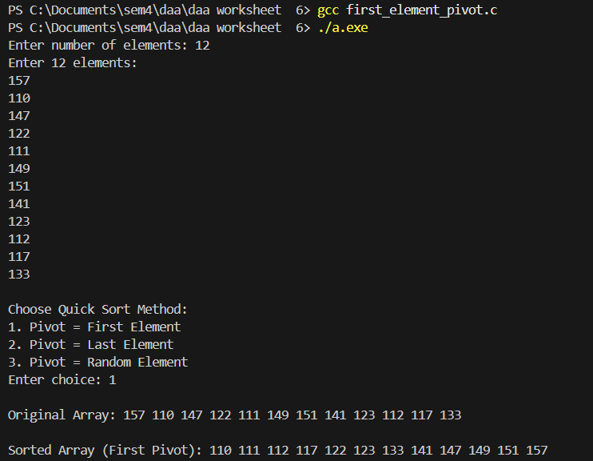

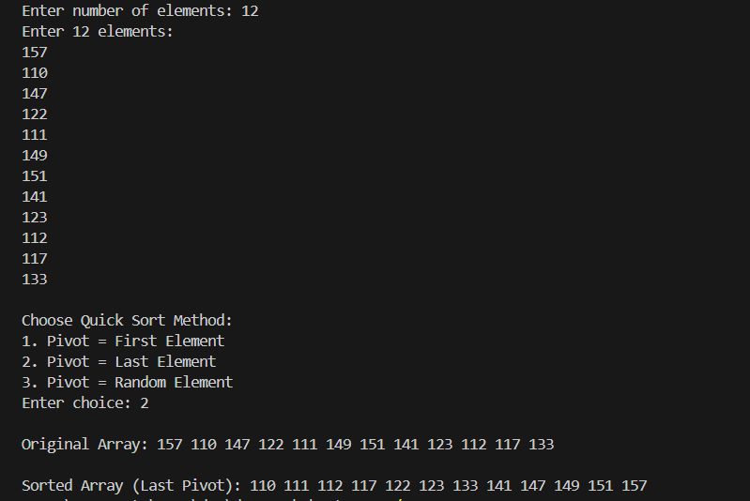
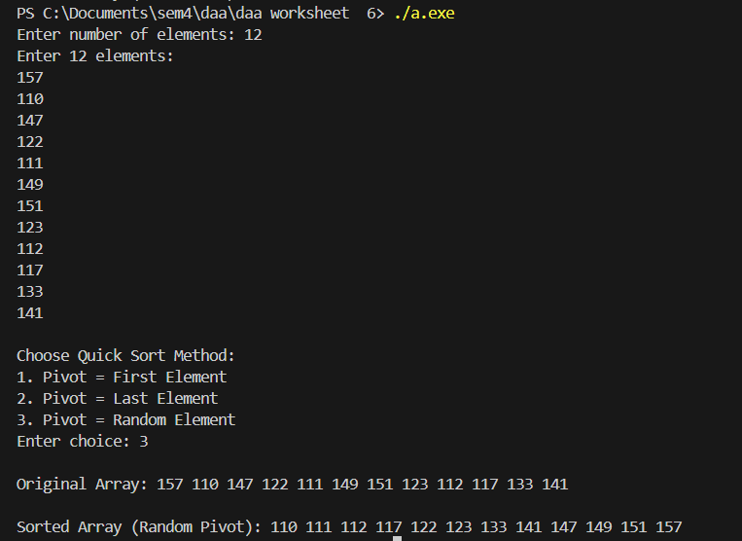

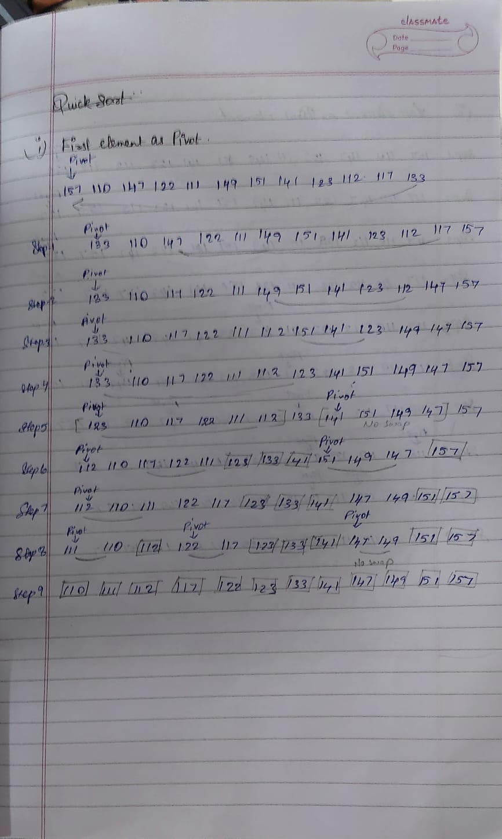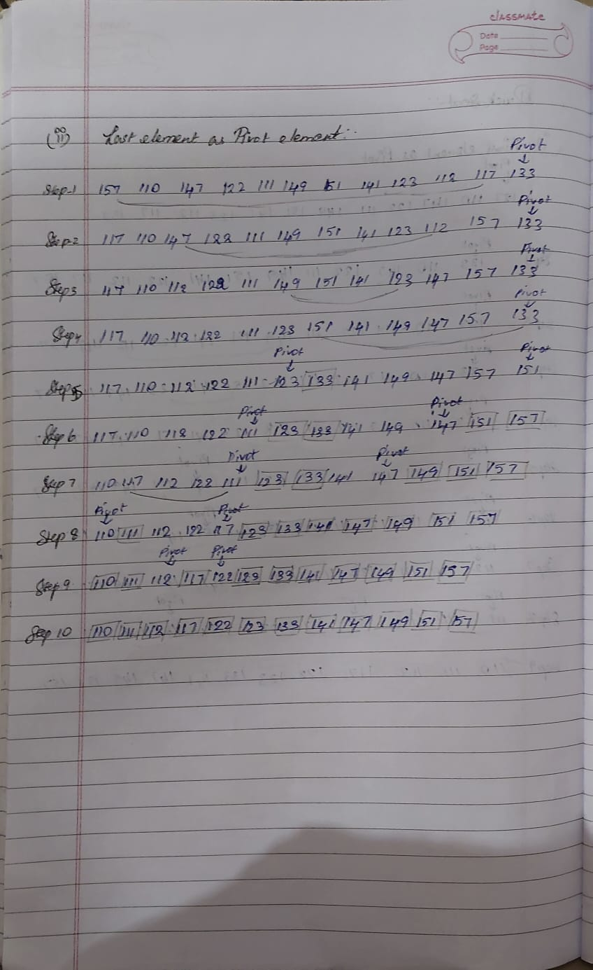
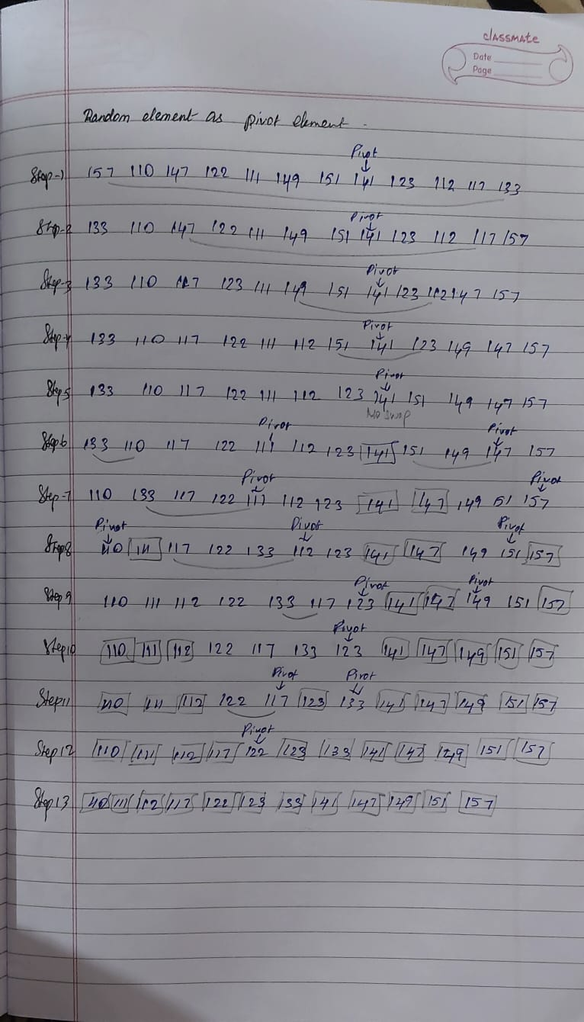
Time Complexity
The time complexity of Quick Sort depends on the choice of the pivot and the resulting partition sizes. In the best and average cases, the pivot divides the array into approximately equal parts, leading to a recursion depth of $\log{n}$, and each level of recursion performs $O(n)$work during partitioning, resulting in an overall time complexity of O(n log n). In the worst case, the pivot is always the smallest or largest element, causing highly unbalanced partitions where one subarray contains $n-1$elements and the other contains none. This increases the recursion depth to $n$, and the total number of comparisons becomes quadratic, giving a worst-case time complexity of O(n²).

Space Complexity
Quick Sort is an in-place sorting algorithm and does not require additional memory for auxiliary data structures. However, it uses extra space due to recursive function calls on the call stack. In the best and average cases, the recursion depth is $\log{n}$, resulting in a space complexity of O(log n). In the worst case, when partitions are extremely unbalanced, the recursion depth can grow to $n$, leading to a space complexity of O(n).

